**FUNCTIONS**

1. User-Defined Function

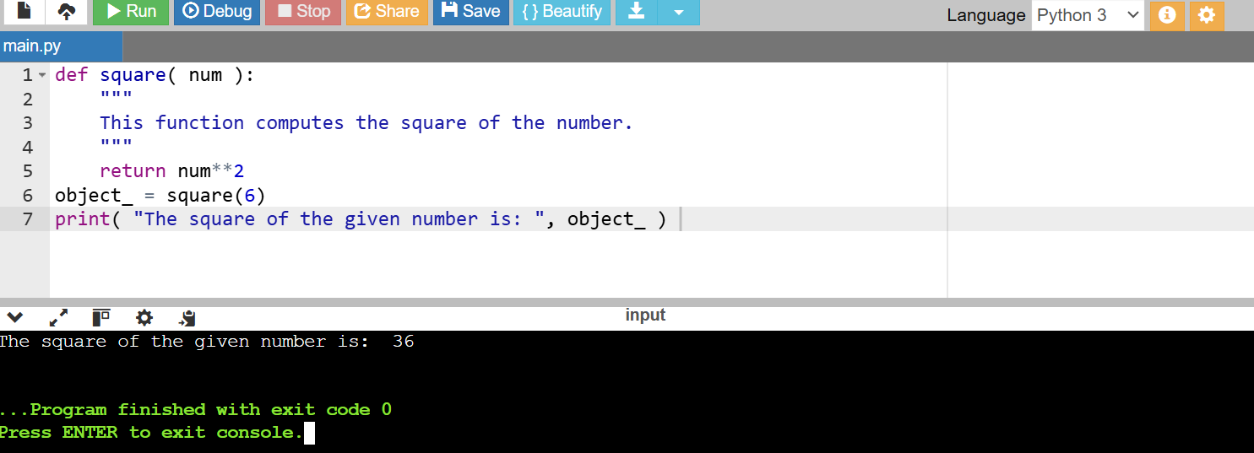

2. Calling a Function

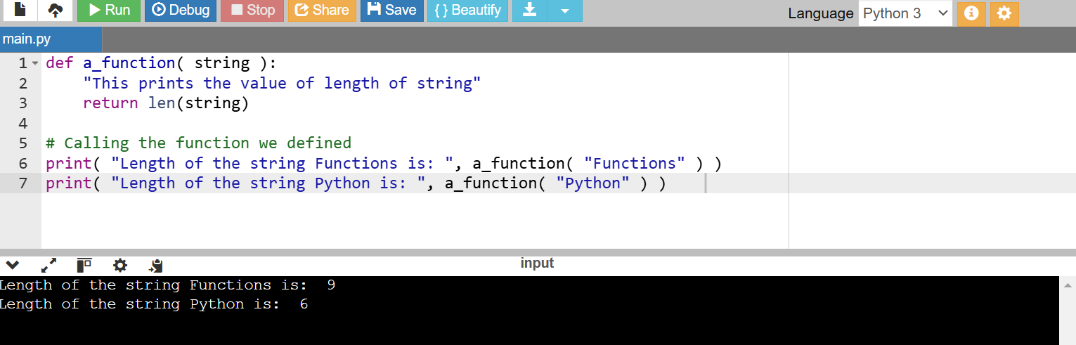

**Pass by Reference vs. Pass by Value**

1. 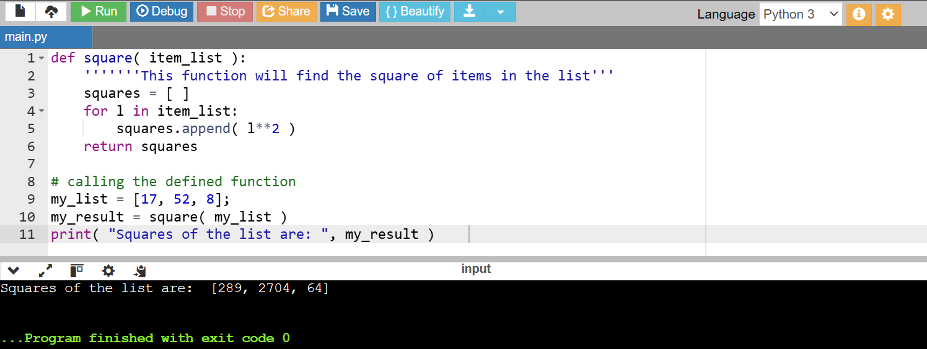

2. return Statement

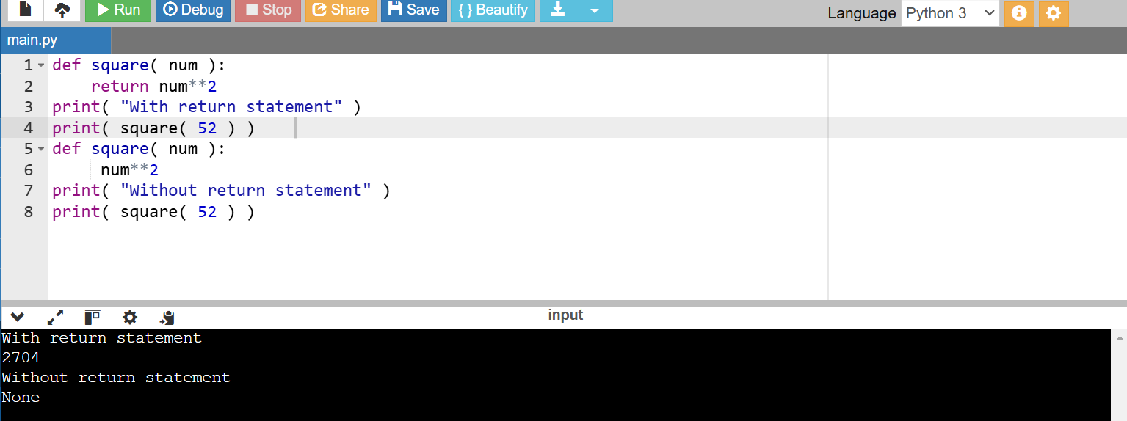

The Anonymous Functions

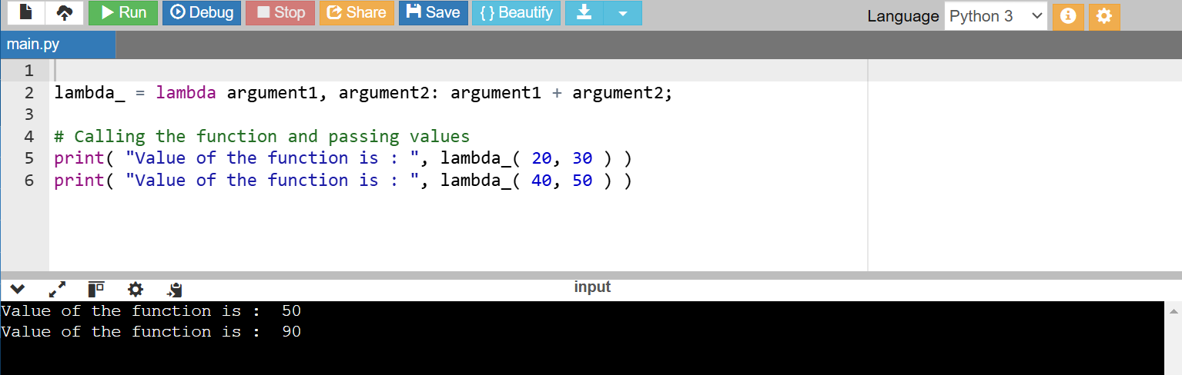

PYTHON BUILT-IN FUNCTIONS:

1. 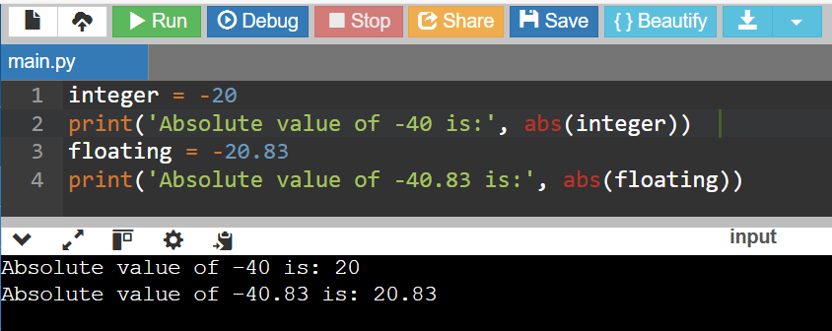

2. 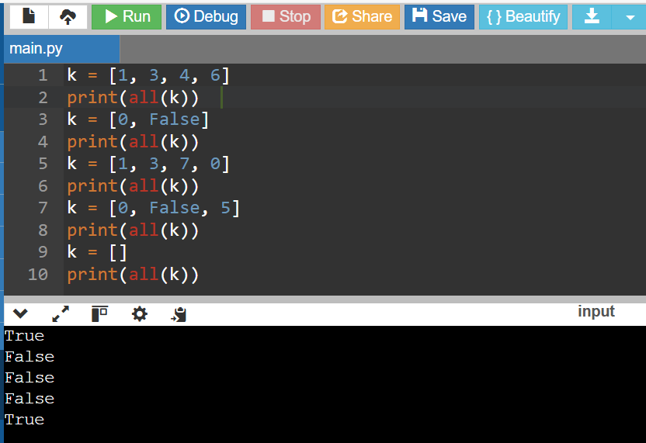

3. 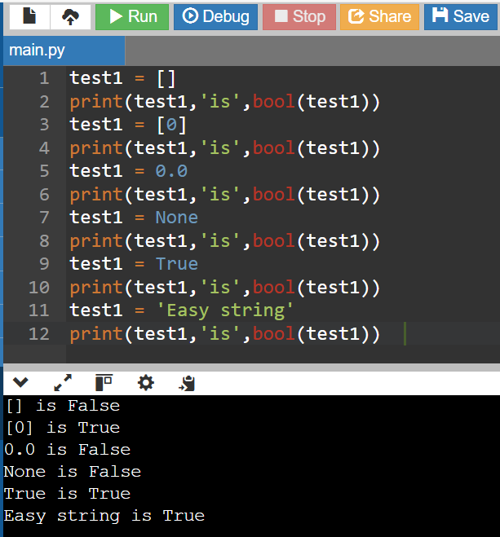

4. 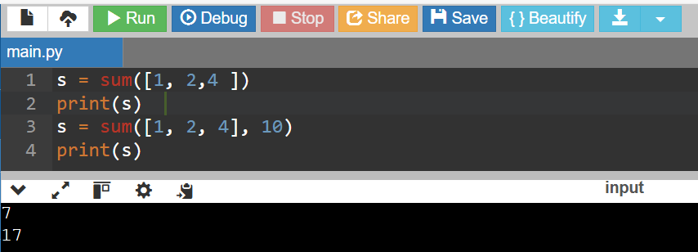

5.

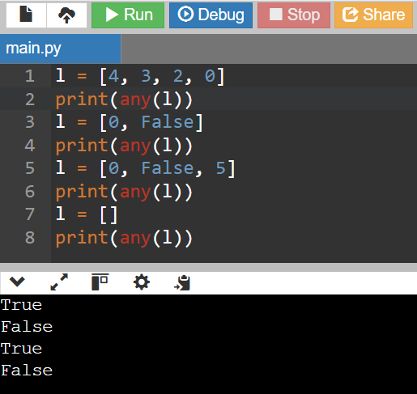

LAMBDA FUNCTIONS:

1.

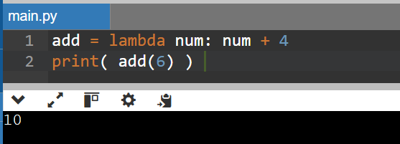

2. 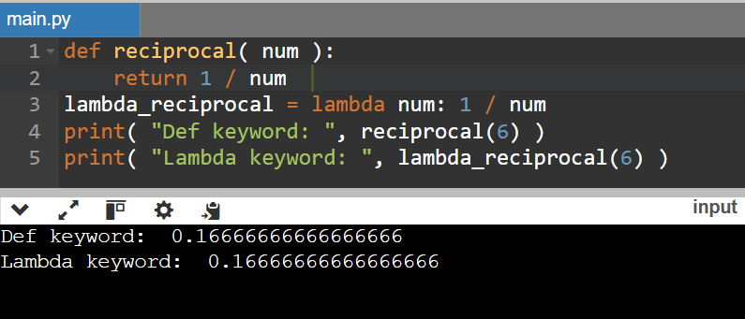

3.

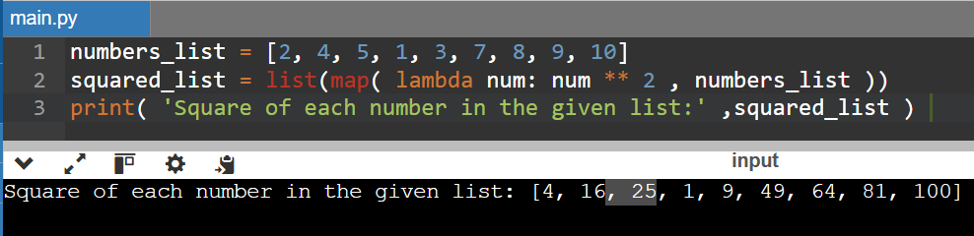

4.

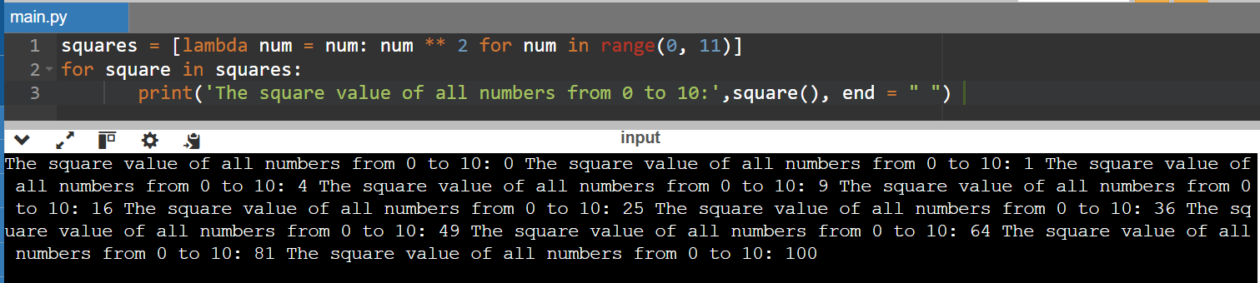

5.

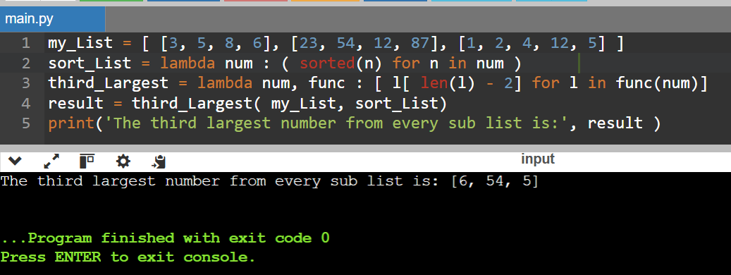

MODULES

1.

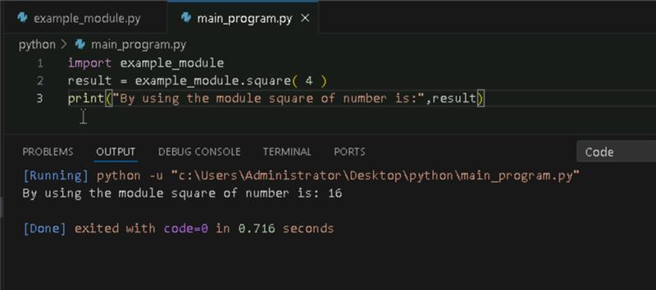

2. **Importing and also Renaming:**

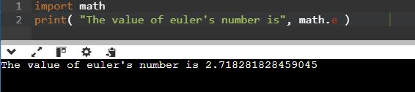

3. Python from...import Statement:

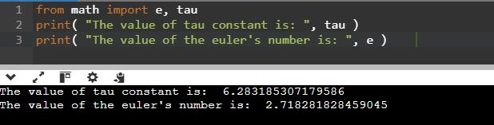

4. Import all Names - From import * Statement:

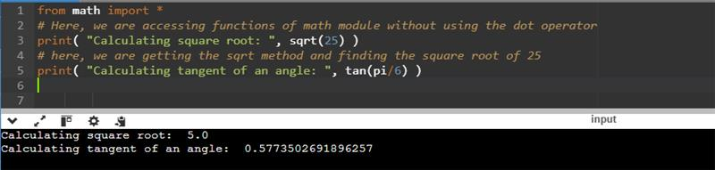

5. Locating Path of Modules:



6. The dir() Built-in Function:

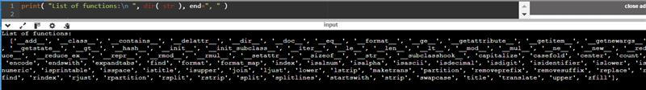

7. Namespaces and Scoping: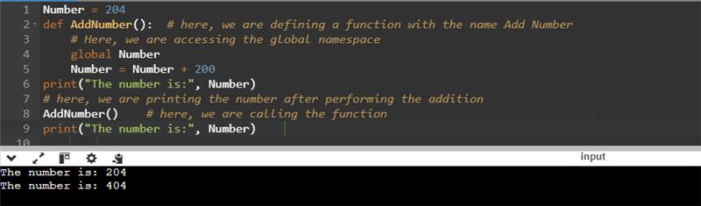

**PYTHON ARRAYS**

1. Accessing array elements:

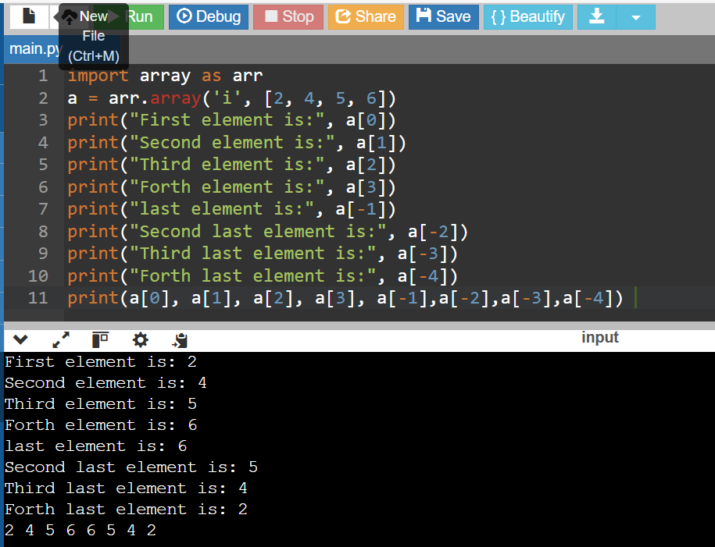

2. Deleting the elements from Array

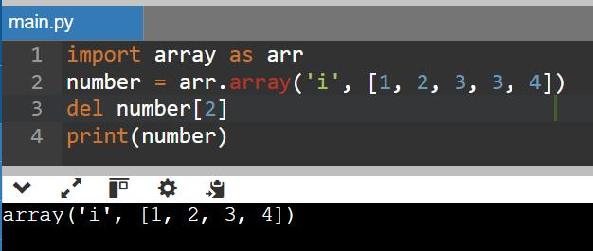

**3**. Adding or changing the elements in Array

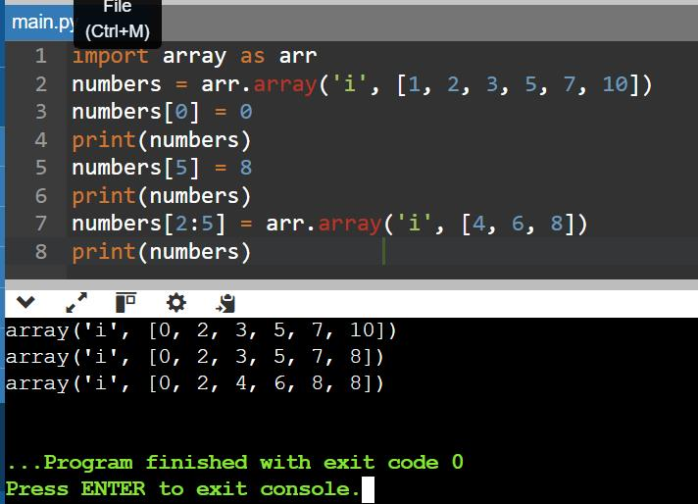

**4**. To find the length of array

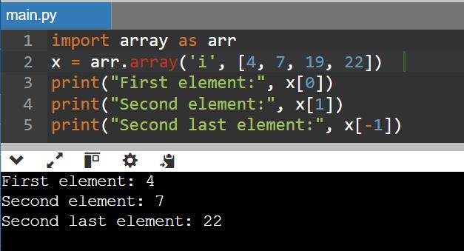

**PYTHON DECORATOR**

**1.**

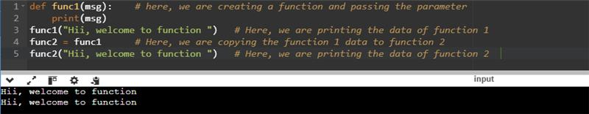

**2**. Inner Function

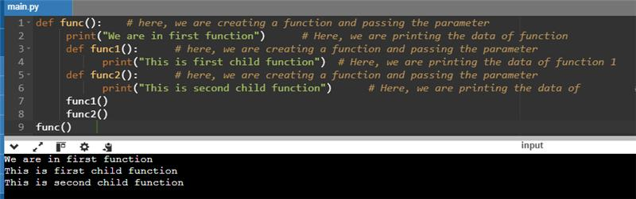

3.

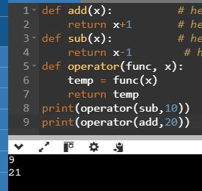

4.

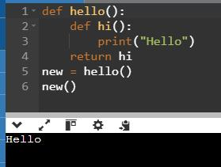

Decorating functions with parameters:

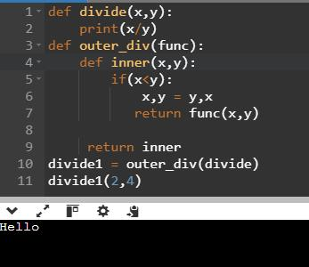

Syntactic Decorator:

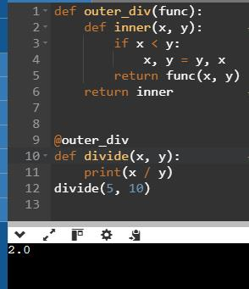

Reusing Decorator

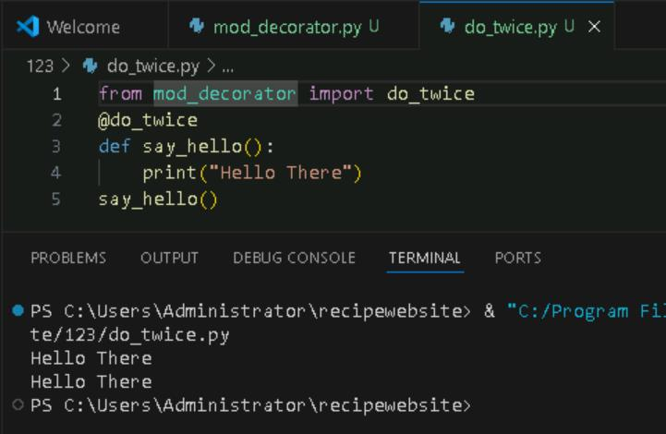

Python Decorator with Argument

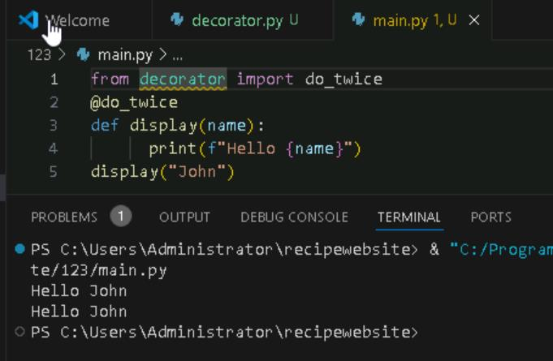

Returning Values from Decorated Functions

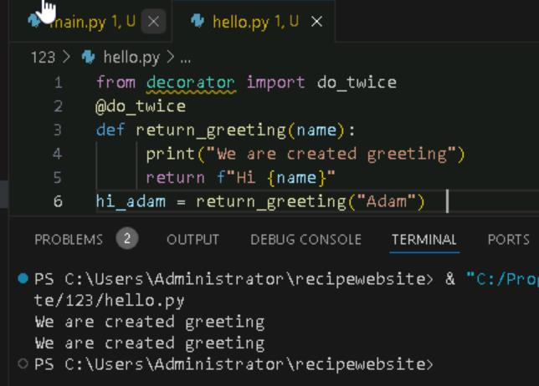

Fancy Decorators

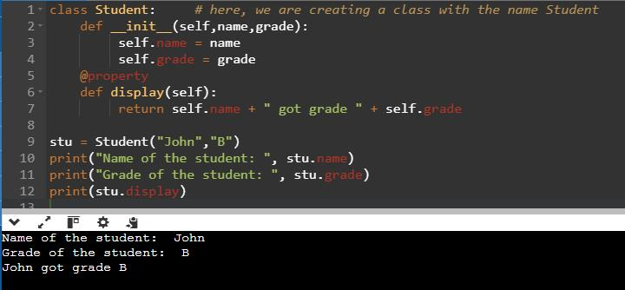

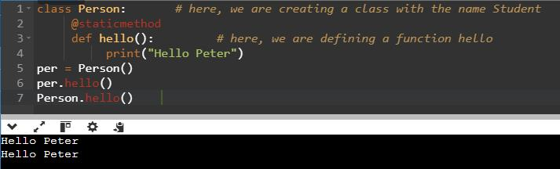

Decorator with Arguments

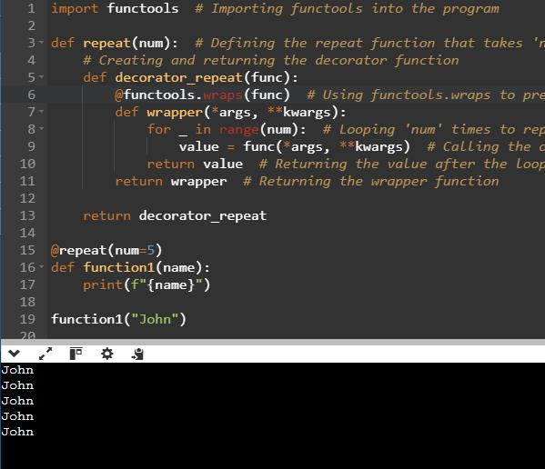

Stateful Decorators

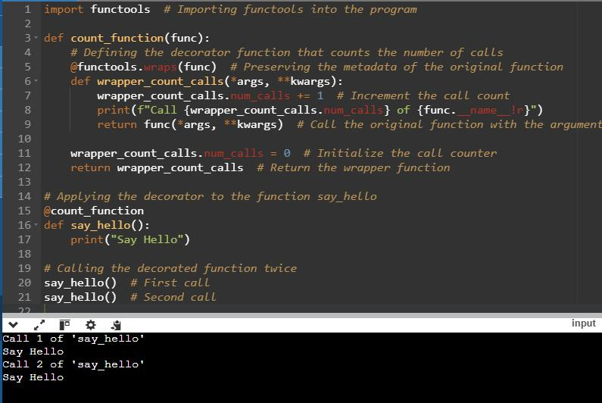

Classes as Decorators

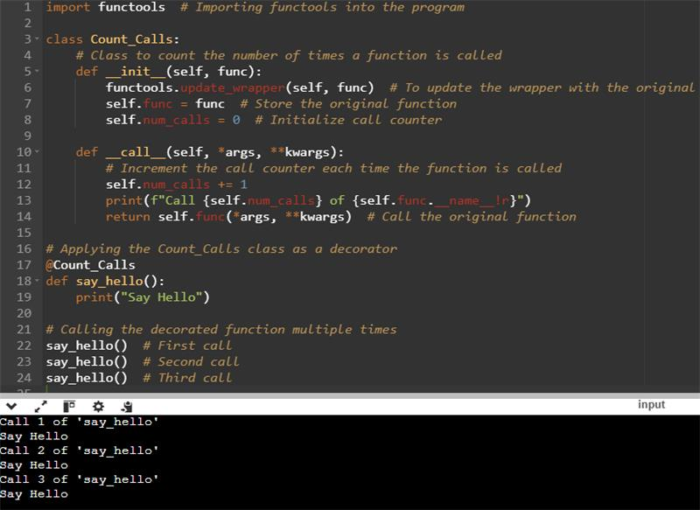

**PYTHON GENERATORS**

To create Generator function in python

Using multiple Yield Statement

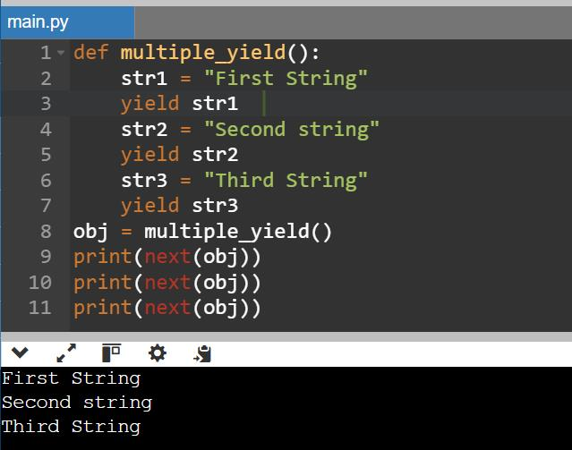

Generator Expression

Multiplication table using Generators

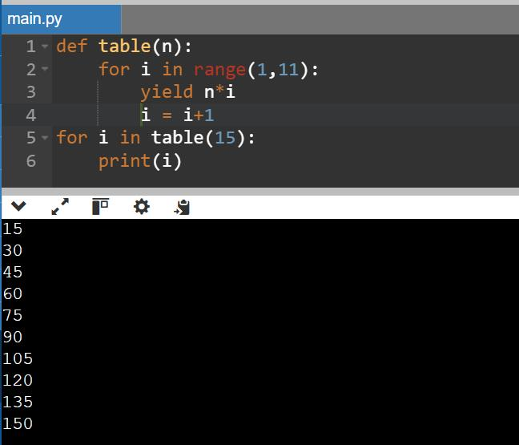

Using next () on Generator Object

**PYTHON BASIC PROJECT**

**1.PASSWORD GENERATOR**

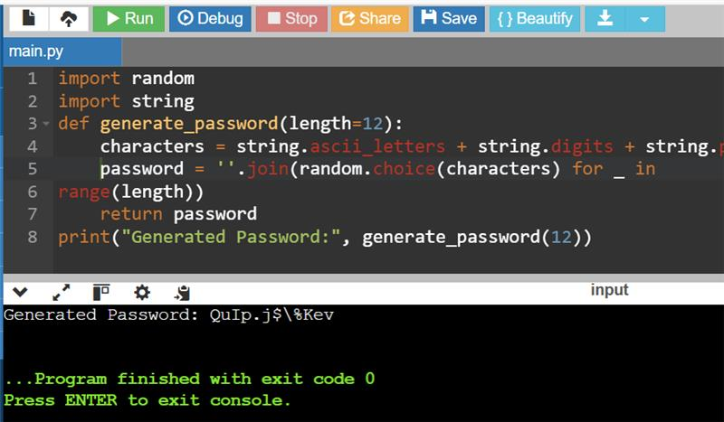

 **2.TO-DO LIST**

**OUPUT**

**3.WEATHER APP (API Based)**

**4.NUMBER GUESSING GAME**

**5.QR CODE GENERATOR**

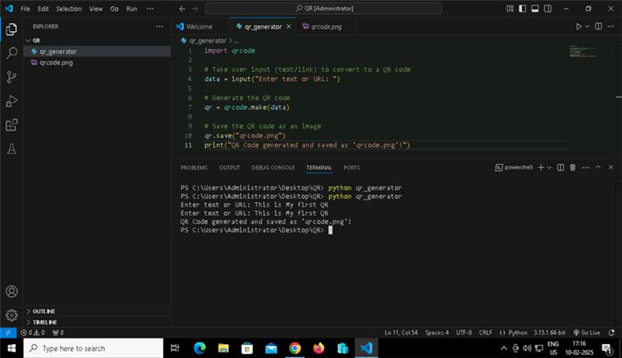

**OUTPUT**

